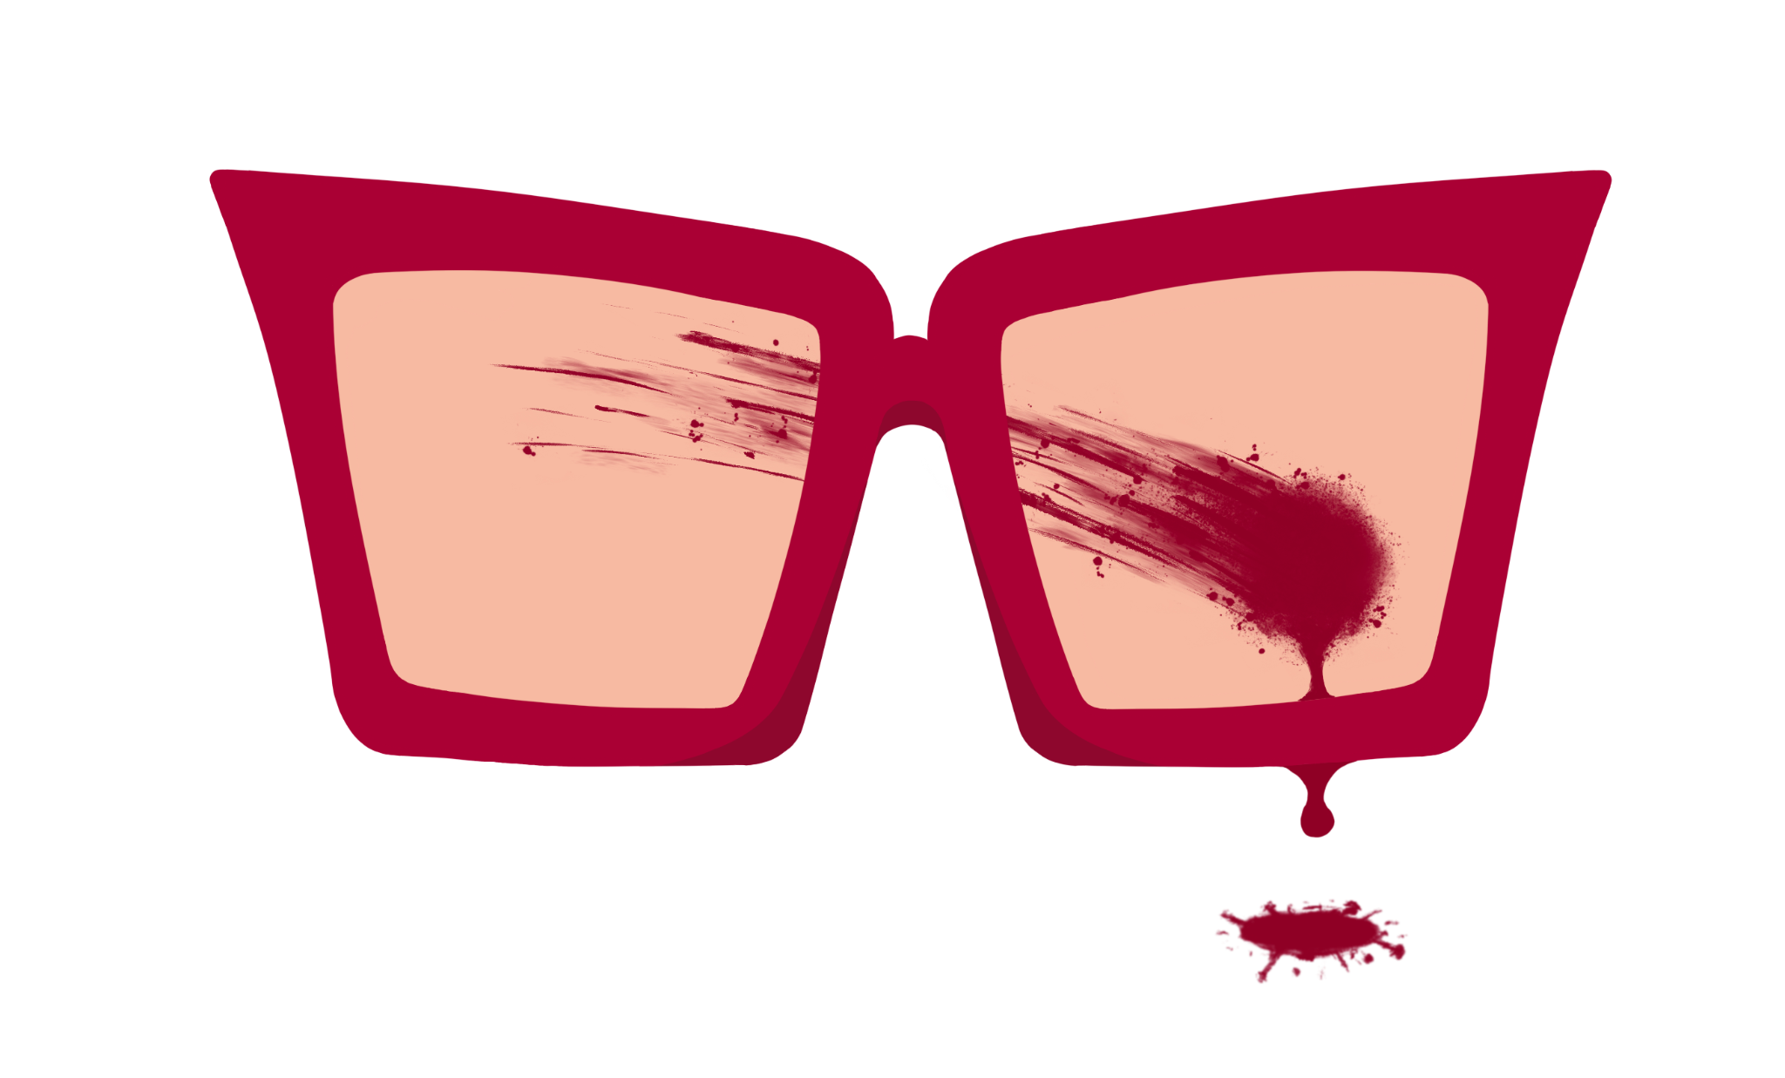 | Ash Rodriguez  8621 Calmosa Ave. Whittier CA 90605  562.968.8002  Ash.rodriguezmakeup@gmail.com
Skills  And  Certifications | Hi, I'm Ashley (Ash) Rodriguez and I’m a freelance Makeup Artist based in Los Angeles. My makeup journey all started with an interest in face painting. My hobby soon grew and in 2013 I began working as a makeup artist. I’ve always strive to continuously expand on my skills and move forward by constantly learning and improving. I'm a positive thinker, an open minded problem solver, and constantly looking for new opportunities to try something new and be a part of a creative team. My skills include airbrushing, prosthetic creation and application, on set grooming, lab work, theater makeup and beauty makeup. I am grateful to have worked with some amazing teams on various projects such as short films, feature films, television, photo shoots, theme park events and more. I am excited to help transform whoever or whatever is needed. Together let’s make your vision a reality  - American Academy of CPR & First Aid, Inc: Blood Borne Pathogens  - Barbicide  - Sanitation Conversation specialist.  - Beauty makeup course Rio Hondo College
Experience | Makeup Designory Substitute teacher  2023  Special FX makeup application instructor. Part-time substitute teaching.  Get Back Project / Sculptor makeup designer  2021 - 2022 In production  Project started with a team of four other Artists. Likeness Makeups of famous Rock stars for online Sketch comedy. My task includes sculpting two of the four band members. Assisting in lifecasting and silicone molds and making Corrective positives. Currently still in production.  Magee FX / Makeup Artist  2017 - 2022, Universal Studios Hollywood CA  Four seasons with the Magee FX team working on Universal’s Halloween Horror Nights event. Latest season of Grinchmas Holiday event. Tasks included airbrush makeup, beauty, and prosthetic application. Lab work summer of 2018. 2019 and 2021, maze and mask supervisor. Responsibilities included an inventory of masks for talent each night—sanitation of masks, any biohazards or needed mask paint and repair.  Shop assistant / Apprentice  2021  Learned skills needed to execute lifecasting with other apprentices and Mentors. Gained valuable experience with different materials, like silicones and urethanes. Corrective positives and mold making. Under the supervision of Kevin Haney.  The Skin Shop / Painter  2018  Jurassic park to Jurassic world the Ride refurbishment. Silicone painting of Dinosaurs. Worked on Stegosaurus back plate scutes, for ride animatronic.  Paramount Pictures / Construction Coordinator Assistant - PA  2021 Melrose Ave. Los Angeles CA  Spent four months helping in payroll to wrap two television shows. One at Fox Studios and the other, the Paramount lot. Expanded my skills in Excel, organization and team leadership. I now have a better understanding of how Productions work and the skills needed to communicate with other departments and employees.  Fox Studios / Production PA  2020-2021 Pico Blvd Los Angeles CA  Six months on set PA for a television show at FOX. Helping each department with their needs and being a part of the COVID safety team. My responsibilities included providing PPE for all cast and crew. Checking in and coordinating cast and crew for Covid testing weekly. And maintaining and sanitizing work areas.  Boneyard FX / Makeup Artist and Workshop intern  2015 - 2016, Universal Studios Hollywood CA  I spent two years with BoneyardFX as an intern and makeup assistant for the Halloween Horror nights pre production team. Worked within the workshop fabricating masks and helping out the different departments from hair to paint.  Knotts Scary Farm / Makeup Artist  2013 -2014, Buena Park CA  Knotts makeup artist for their Knotts Scary Farm seasonal event. Skills in theater makeup and airbrush application. As my first makeup job, it expanded my creativity and problem solving skills, showing me how to work with others to achieve a common goal. It ultimately ignited my passion for working in the arts and in team settings.

Makeup Department
2022 Vice and Virtue (Makeup Dept Head)
Still (makeup artist) (pre-production)
2022 Sanguisuga (makeup artist)
2022 Bloody Bridgette (makeup artist)
2021 Kinigra TV (makeup artist)
2021 Blue Moon Ball (key makeup artist)
2020 Varidesk Commercial (makeup artist)
2020 MAX a short film (makeup dept Head)
2020 Disclosure , Music video (makeup Artist)
2019 Night Drive (makeup dept head)
2019 The Return (makeup artist)
2019 Man and the Smoking King (makeup dept head )
2019 Zorpo (Short) (makeup artist)
2018 LMLT Rotten Science Tru TV (Hair and Makeup PA)
2017 The Haunt (TV Series) (makeup artist - 1 episode)
The Haunt (2017) ... (makeup artist)
2017 Cash Cash & Dashboard Confessional: Belong (Music Video) (key makeup artist)
2017 Good Night (Short) (special makeup effects artist)
2016-2017 The Chuckie Perez Show (TV Series) (assistant makeup artist - 6 episodes)
- Fifteen (2017) ... (assistant makeup artist)
- Thirteen (2017) ... (assistant makeup artist)
- Twelve (2016) ... (assistant makeup artist)
- Eleven & Ten (2016) ... (assistant makeup artist)

Education | Rio hondo College / Certification in Makeup Artistry  2015 Whittier CA  I attended a four week course about makeup application and the industry as well as color theory and in depth product breakdowns. Here I gained experience doing makeup on others, going over different types of artistry such as bridal, film and photography.  Cypress Community College / Theater makeup Program & Special FX  Two month course, theater makeup application and design. Special FX course included intro to sculpture and foam as well as stone molds.

